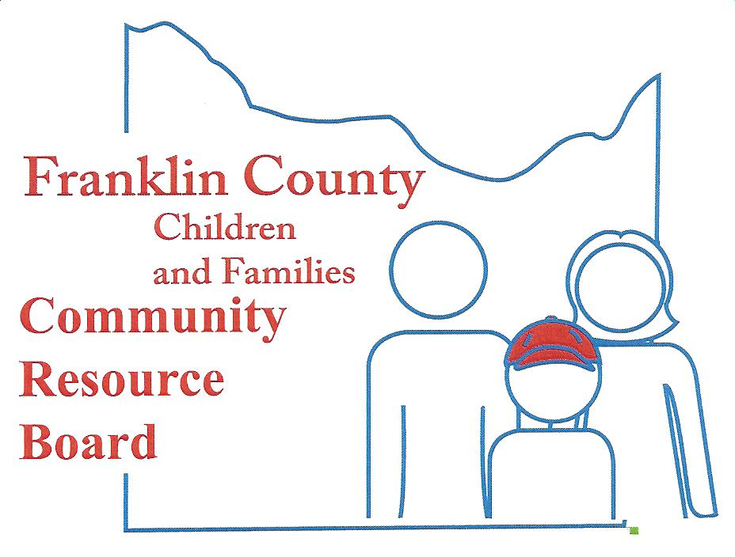

Community Resource Board
Meeting Agenda: June 25, 2018
30 South McKinley ~ Union, MO
Time: 5:30 pm.

- Call the meeting to order

- Welcome Guest and Introductions

- Approval of minutes from last meeting

- Finance Committee
  - Financial Reports
  - Projections/Actual
  - Service Expenditures

- Personnel Committee

- Selection and Review Committee

- New Business
  - Life House Report
  - Leader in Me Request – New Haven

- Old Business
  - Trauma Informed Community – Franklin County Cares Update and Request
  - Needs Assessment Update
  - Update from Irv Jensen

- Executive Director's Report
  - Franklin County System of Care
  - Homeless Task Force
  - Community Resources

- Announcements

- Adjournment

NEXT MEETING – August 27, 2018

