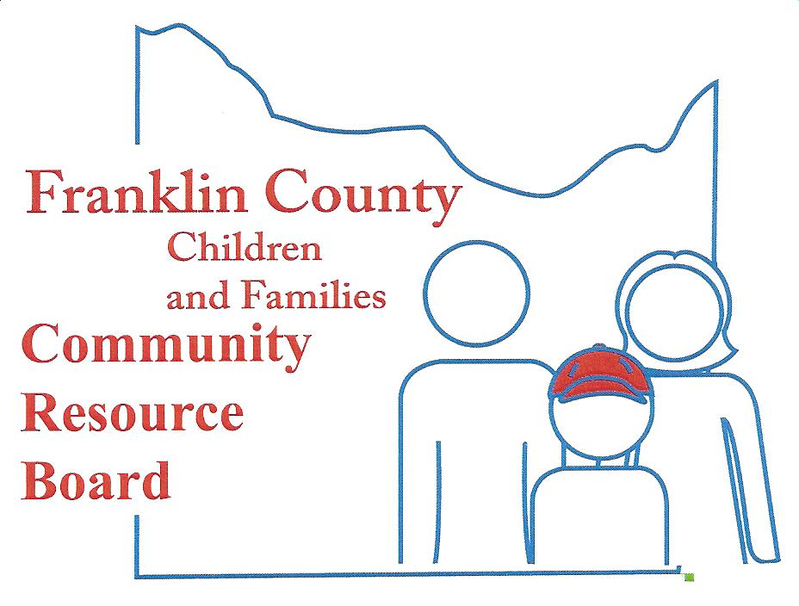

Community Resource Board
Meeting Agenda: June 24, 2019
30 South McKinley ~ Union, MO
Time: 5:30 pm.

- Call the meeting to order

- Welcome Guest and Introductions

- Approval of minutes from last meeting

- Finance Committee
  - Financial Reports
  - Projections/Actual
  - Service Expenditures

- Personnel Committee

- Selection and Review Committee

- Old Business
  - FCCRB Audit

- New Business
  - New Haven Elementary Leader in Me
  - Next Board Meeting?

- Executive Director's Report

- Announcements

- Closed Session (Close session pursuant to RSMo 610.021 Section 2 Leasing, purchase or sale of real estate by a public governmental body where public knowledge of the transaction might adversely affect the legal consideration therefor.)

- Adjournment

NEXT MEETING – , 2019

