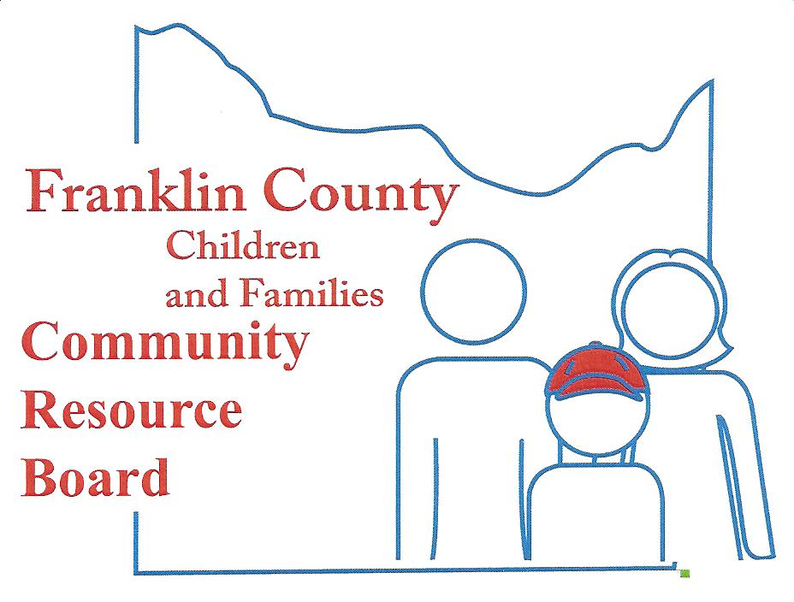

Community Resource Board
Meeting Agenda: February 26, 2018
30 South McKinley ~ Union, MO
Time: 5:30 pm.

- Call the meeting to order

- Welcome Guest and Introductions

- Approval of minutes from last meeting

- Finance Committee
  - Financial Reports
  - Projections/Actual
  - Service Expenditures

- Personnel Committee

- New Business
  - 2018 Needs Assessment for Children and Families Proposal
  - School Personnel Survey - Proposal
  - County-wide Resource Development, Promotion, and Recrutiment
  - Organizational Development including Strategic Planning, Board Development and Marketing Efforts - Proposal
  - Leader in Me – Continued growth and development

- Old Business
  - Marketing and Outreach Efforts
  - Trauma Informed Community Update

- Executive Director's Report

- Announcements

- Selection and Review Committee (Close session pursuant to RSMo 610.021 Section 12 of the Franklin County Children and Families Community Resource Board. The purpose of which is to evaluate request for funding and make determinations on future contracts for services.)

- Adjournment

NEXT MEETING – March 26, 2018

