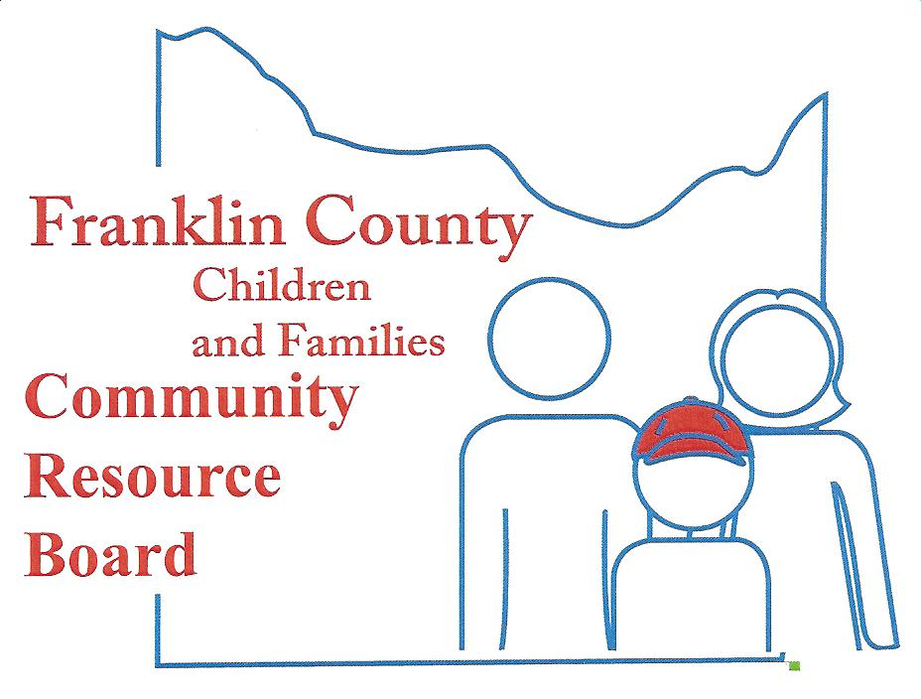

Community Resource Board
Meeting Agenda: January 22, 2018
30 South McKinley ~ Union, MO
Time: 5:30 pm.

- Call the meeting to order

- Welcome Guest and Introductions

- Approval of minutes from last meeting

- Finance Committee
  - Financial Reports
  - Projections/Actual
  - Service Expenditures
  - 2018 Budget

- Personnel Committee

- Selection and Review Committee

- New Business

- Old Business
  - Marketing and Outreach Efforts
  - Trauma Informed Community Update

- Executive Director's Report

- Announcements

- Adjournment

NEXT MEETING – February 26, 2018

