Theory of Change – In-depth Process and Example

Identifying Long-term Goals (Outcomes)
In the first stage of theory development, TOC participants discuss, agree on, and get specific about, the long-term goal or goals. This can be done in a variety of ways, (see our facilitator’s guide), but the important thing is to set a good, clear outcome. The quality of the rest of the theory hinges on doing this right!
Then, TOC participants start to design a simple map of the preconditions required to bring about the long-term goal. Beginning the mapping process helps stakeholders to visualize and prioritize their goals as well as specify what they expect to change and for which outcomes they want to be held accountable.
Stage 1: Identifying Goals and Outcomes

Backwards Mapping and Connecting Outcomes
After the first step of laying out the long-term goals and a simple change framework, comes a more detailed stage of the mapping process. Building upon the initial framework, we continue to map backwards until we have a framework that tells the story we think is appropriate for the purposes of planning. Sometimes, this will require much more detail because stakeholders want to identify the “root” causes of the problem they hope to resolve. In other cases, the map will illustrate three or four levels of change, which display a reasonable set of early and intermediate steps toward the long term goal.
Because this work is challenging and most social change programs or broader initiatives have a lot of moving parts, change frameworks usually go through many revisions. Outcomes are added, moved and deleted until a map eventually emerges that tells a story the group can agree on. For the users, the debate is often the most valuable component of TOC because they are now jointly defining the expectations, assumptions and features of the change process. TOC participants are required to make explicit, and agree upon, the underlying logic of the initiative improving which improves the productivity and accountability.
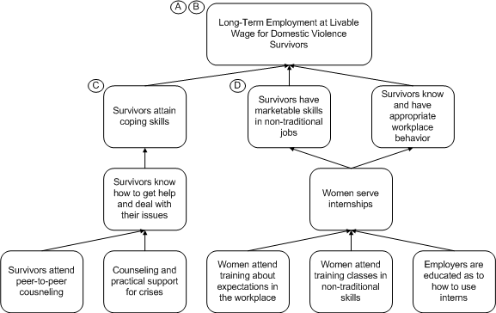

Commentary
For the Project Superwomen example, program designers asked themselves what women would need if they were going to have long-term employment. Specifically, how would the project’s participants achieve the three identified preconditions (coping skills, marketable skills, and appropriate workplace behavior) to the ultimate outcome? That required identifying what it would take for women to achieve coping skills, job skills and knowledge of workplace behavior.

Drawing Connections
We continue illustrating how the long-term outcomes are linked to the intermediate ones. In stage 1, we connected the final long-term outcome of employment at a livable wage to the three intermediate outcomes with solid, arrowed lines, indicating that they are preconditions. This process holds for the intermediate outcomes as well. For “Survivors know how to get help and deal with their issues” we use arrowed lines to show that the two outcomes below it are direct preconditions of it.
Illustrating connections helps to spot-check the initiative’s logic as well as identifying where the initiative should intervene. Following the logical path from outcome to proposed precondition often points out inconsistencies. TOC participants are able to readjust their frameworks and drop or add outcomes as necessary. They also understand when these outcomes will take place on their own or require an intervention by the initiative to make it happen, such as a program activity.

Completing the Outcomes Framework
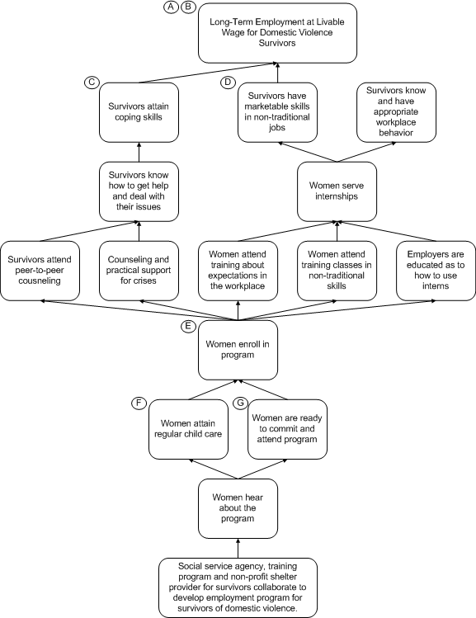
Commentary
To complete the framework the preconditions are fleshed out all the way back to the initial condition—a coalition of organizations working to develop employment programs for domestic violence survivors. Again explaining preconditions remains important, hence for “Women enroll in program” the assumption:
The program cannot help all women and so entry into the program must include screening so that women who have sufficient literacy and math skills to take the training, and lives stable enough to attend classes are admitted. The program does not have the resources to handle providing basic skills or major social services.
Early on in the planning process, the group realized that they only had the resources to provide assistance to women who had already begun to stabilize their own lives. The program could take care of the temporary issues, such as emergency housing but not something more permanent or serious, such as substance abuse.
Because of the relative simplicity of this framework, it seems as if the connections are all given. At this stage, you might think: “If it’s below another outcome, then it must be a precondition. Why all the arrowed lines?” While in this example, it is not difficult to organize preconditions, in more complex frameworks, boxes can be near each other without a direct relationship, connections can be made across the framework, etc. For the clarity of the framework, connections are irreplaceable.

Identifying Assumptions
As previously discussed, the program designers realized that the program could only effectively work with women who had already begun to stabilize their lives. Any initiative is only as sound as its assumptions. Unfortunately, these assumptions are too often unvoiced or presumed frequently leading to confusion and misunderstanding in the operation and evaluation of the initiative. To address that problem, TOC documents assumptions to ensure agreement for planning and posterity.
For the long-term outcome: “Long-term employment at livable wages for domestic violence survivors”, these assumptions must be met for the outcome to be achievable:
A. There are jobs available in non-traditional skills for women.
B. Jobs in non-traditional areas of work for women, such as electrical, plumbing, carpentry and building management are more likely to pay livable wages and are more likely to be unionized and provide job security. Some of these jobs also provide a ladder of upward mobility, from apprenticeship to master, giving entry-level employees a career future.
These two assumptions make explicit why the participants believe this program can work: there are jobs in non-traditional work and that those jobs can offer better financial and professional
For the outcome: “Survivors attain coping skills”, (which is also a precondition of the long-term outcome): the assumption is:
C. Women who have been abused need more than just skills, they need to be emotionally ready for work as well.
Again, this assumption clarifies why and how this program is different from traditional job-training programs, i.e., the special psychological supports needed for the initiative’s clients.
For the outcome: “Survivors have marketable skills in non-traditional jobs”, it is assumed that:
D. Women can learn non-traditional skills and compete in the marketplace.
This assumption is an article of faith that women can compete and succeed in this new labor market.
Documenting assumptions and justifications is a continuous process. As outcomes are added and moved on the framework, it remains necessary to question and explain how and why they are necessary.

Developing Indicators
The Indicators stage is when details are added to the change framework. This stage focuses on how to measure the implementation and effectiveness of the initiative. By collecting data on each outcome, the initiative can identify what it is or isn’t happening and find out why.
Each indicator has four parts: population, target, threshold and timeline. But you can forget the jargon. Simply put, for each indicator you want to ask:
Who is changing? (women enrolled in the program)
How many do we expect will succeed? (perhaps 90% of the enrolled women)
How much is good enough? (a $12 per hour job for at least six months?)
By when does this outcome need to happen? (perhaps within two months of graduation)
- Indicator is the actual variable being measured, such as average test scores or proficiency in a particular skill.
- Population is the group that you are measuring, such as a program’s clients.
- Threshold represents the minimum for the outcome to be successfully achieved. (E.g. the threshold for a successful election between two candidates is 51% of the vote; if there were three or more candidates, the threshold would be lower, because only a majority of the votes would be required to be successful.)
Here are some sample indicators for Project Superwomen:
Outcome 1: | Long-term employment at a livable wage for domestic violence survivors
Indicator : | Employment
Population: | Program graduates
Threshold: | Remain in job at least 6 months and earn at least $12 per hour
Outcome 2: | Survivors have marketable skills in non-traditional jobs
Indicator : | Skill in electrical, plumbing carpentry or building maintenance
Population: | Program participants
Threshold: | Successfully complete internship
Outcome 2: | Survivors have marketable skills in non-traditional jobs
Indicator : | Program graduation
Population: | Program participants
Threshold: | Do graduate (yes/no)

Identifying interventions
After laying out the near complete change framework, we now focus on the role of interventions (those things that the program (or initiative) must do to bring about outcomes).
Interventions
At this stage, note that some arrows have solid lines while others are dashed. The solid lines represent connections that will occur without the need for intervention. As long as the prior preconditions are met, these outcomes will be met. We represent interventions, an initiative’s program activities, as arrows with dashed lines for three reasons:
- We believe the outcomes those arrows lead to will not occur at a sufficient level without an intervention.
- They represent actions by the initiative and thus something that the initiative is responsible for
- Because these outcomes are control variables, they need to be measured to evaluate the interventions’ effectiveness.
By identifying interventions, the stakeholders explain how their work is going to change the community. Until this point, the change framework has been like a gumbo recipe without directions, a literal listing of intermediate ingredients—roux, shrimp, onions, okra, etc. But until this point our “recipe” hasn’t explained explain how these components are used and put together, i.e., how to make roux by browning flour in hot oil; when to add the shrimp (previously peeled and cleaned), etc. The interventions explain what the stakeholders are going to do to achieve their desired outcomes. Hence the first intervention (1), an outreach campaign, is of course necessary to publicize the program. While this example seems obvious, the point is again to be clear about what the stakeholders expect the initiative to do—something that is often taken for granted, but never clearly or consistently expressed.
We also identify each intervention with boxed numbers. Often a dashed interventions arrow will have multiple boxes because the outcome requires multiple activities for it to happen.
Spot Checking
At every stage of the TOC process, there is a need for stakeholders to question whether new revelations reveal an inconsistency in their logic: Does specifying interventions highlight an important gap in the outcomes framework? Do any of the assumptions suggest an additional change pathway (with additional early and intermediate outcomes)? Stakeholders should ask themselves if what they are creating “makes sense” by thinking about whether their map reflects a plausible theory, and whether the set of interventions are actually feasible for them to implement, given the resources they have at their disposal.

